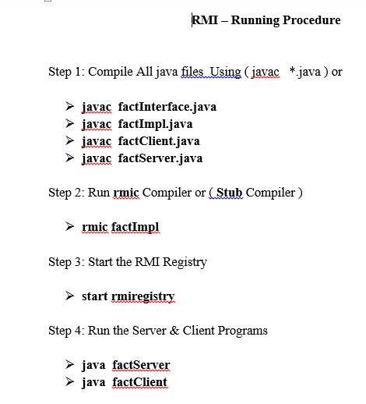

**factServer.java**

import java.rmi.*;

import java.rmi.registry.*;

import java.rmi.server.*;

public class factServer

{

public static void main(String args[])

{

//System.setSecurityManager(new RMISecurityManager());

try

{

factImpl pim = new factImpl();

Naming.rebind("mani", pim);

System.out.println("\n Server is ready...");

}

catch(Exception e) { }

}

}

**factClient.java**

import java.rmi.*;

import java.rmi.registry.*;

import java.rmi.server.*;

import java.io.*;

import java.net.*;

public class factClient

{

public static void main(String args[]) throws RemoteException

{

try

{

int factorial;

int Number=0;

String mani="rmi://Localhost/mani";

factInterface pi = (factInterface) Naming.lookup(mani);

BufferedReader ber=new BufferedReader(new InputStreamReader(System.in));

System.out.print("\n Enter Number for Factorial : ");

String temp=ber.readLine();

Number = Integer.parseInt(temp);

factorial = pi.find_fact(Number);

System.out.println("Factorial is : " + factorial);

}

catch(Exception e)

{

System.out.println("System Exception" + e);

}

}

}

**factImpl.java**

import java.rmi.*;

import java.rmi.registry.*;

import java.rmi.server.UnicastRemoteObject;

public class factImpl extends UnicastRemoteObject implements factInterface

{

public factImpl() throws RemoteException

{

super();

try

{

//Naming.rebind(name,this);

}

catch(Exception e) { }

}

public int find_fact(int n1) throws RemoteException

{

int ans=n1;

n1--;

while(n1 > 0)

{

ans = ans * n1;

n1--;

}

return ans;

}

}

**factInterface.java**

public interface factInterface extends java.rmi.Remote

{

int find_fact(int n) throws java.rmi.RemoteException;

}